# CptS 223 Homework #4 - Graphs

Please complete the homework problems on the following page using a separate piece of paper. Note that this is an individual assignment and all work must be your own. Be sure to show your work when appropriate.

**1. [13]** Define these terms as they relate to graph and graph algorithms:  
 Use mathematical terms where appropriate.

**Graph** – A collection of vertices that are connected by edges.  
**Vertice** – A point that represents a piece of data in a graph.   
**Edge** – A path between two vertices represented as a line.  
**Undirected Graph** – A graph where edges can be traversed in either direction.  
**Directed Graph** – A graph where edges can only be traversed in one direction.  
**Path** – A sequence of vertices where the length is the number of edges.  
**Loop** – A path where consecutive vertices are the same.  
**Cycle** – A directed graph where the start vertex is the same as the ending vertex.   
**Acyclic** – A graph without any cycles present.  
**Connected** – A graph where there is a path from every vertex to every other vertex.  
**Sparse** – A graph where there is a small amount of edges compared to the maximum amount of possible edges that can exist in the graph.  
**Weight** – The cost associated with traversing an edge.

**2. [4]** Under what circumstances would we want to use an adjacency matrix instead of an adjacency list to store our graph?  
  
If the graph being used is dense it is better to us an adjacency matrix.  
  
  
  
  
  
  
**3. [6]** Name three problems or situations where a graph would be a good data structure to use:  
  
1. Travel plan

2. Traffic map

3. Map of Network

**4. [4]** What kind of graph is this?  
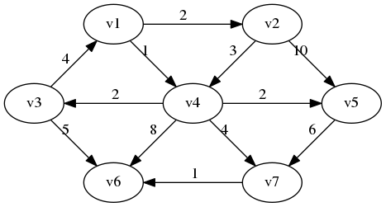- Directed Acyclic Graph

**5. [4]** Identify the loop in this graph:

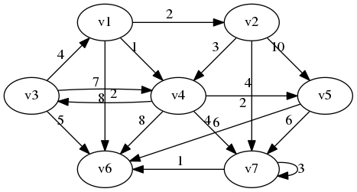- The loop is (v7, v7)

**6. [4]** How many vertices and edges are in this graph:

|  |  |
| --- | --- |
|  | Vertices - 7  Edges - 17 |

**7. [6]** Are these cyclic or acyclic graphs?

|  |  |
| --- | --- |
|  | Cyclic?  Yes ***No*** |
| Image result for cyclic graph | Cyclic?  ***Yes***  No |
| Image result for acyclic graph | Cyclic?  Yes ***No*** |

**8. [5]** A tree is a particular kind of graph. What kind of graph is that?

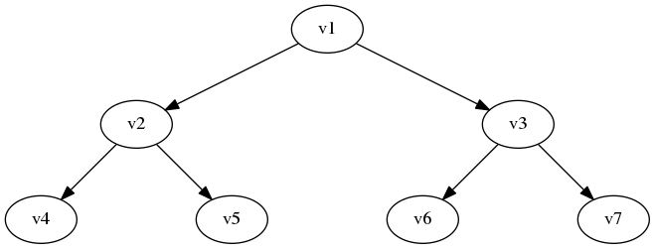

-Directed Acyclic Graph

**9. [4]** What is the difference between a breadth-first search and a depth first search?

Breadth-first search traverses like a level order search, by moving through the graph in layers starting at a vertex and ending with the vertex that is furthest from the starting point. Depth first search starts at a vertex and goes as far as it can before backtracking, eventually visiting each node.

**10. [10] Dijkstra's Algorithm.** Use Dijkstra's Algorithm to determine the shortest path starting at **A**. Note that edges without heads are bi-directional. To save time, you do not have to add items to the "priority queue" column after it has been discovered (listed in the "distance" column). Use the table below to show your work.

What’s the shortest route (by weight) from A to C?

A, B, D, F, E, C  
  
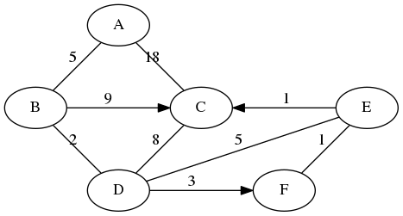

|  |  |
| --- | --- |
| **Node: Distance** | **Priority Queue** |
| **0** | A |
| **5**  **18** | B  C |
| **14**  **7** | C  D |
| **15**  **12**  **10** | C  E  F |
| **13** | C |
| **11** | E |
| **12** | C |
|  |  |
|  |  |

**11. [10] Topo sort.** Show the final output of running Topo Sort on this graph:

|  |  |
| --- | --- |
|  | What’s the vertice with the largest degree and its value?  MAD2104: 8  What’s the vertice with the highest indegree and its value?  CDA4101: 3  What’s the vertice with the highest outdegree and its value?  MAD2104: 6 |

Topo sort output:

{MAC3311, COP3120, MAD2104, COP3337, CAP3700, MAD3512, MAD3305, CDA4101, COP4555, COP3530, COP4540, CIS4610, COP5621, CDA4400, COP4610, COP4225}